**Assignment Group C -Pract 11 (Unit 5 & 6)**

|  |  |  |  |  |  |  |
| --- | --- | --- | --- | --- | --- | --- |
| **W (4)** | **C (4)** | **D (4)** | **V(4)** | **T (4)** | **Total** | **Sign** |
|  |  |  |  |  |  |  |

**Date of Performance ____________**

**Date of Completion** :_____________

**Problem Definition:**

Write a program for DNS lookup. Given an IP address input, it should return URL and vice versa.

**1.1 Prerequisite:**

1. IP Address and OSI & TCP/IP Model.

2. Role of different servers.

3. Working of internet.

**1.2 Learning Objectives:**

1. Understand what is Domain Name System and DNS lookup working.

2. Understand what is DNS Structure and Hierarchy.

**1.3 New Concepts:**

1. Name Server and Domain Name System.

2. DNS lookup, Zone

**1.4 Theory**

**1.4.1 Introduction**

The Domain Name System (DNS) is a hierarchical decentralized naming system for computers, services, or other resources connected to the Internet or a private network. It associates various information with domain names assigned to each of the participating entities.

it translates more readily memorized domain names to the numerical IP addresses needed for locating and identifying computer services and devices with the underlying network protocols. By providing a worldwide, distributed directory service, the Domain Name System is an essential component of the functionality on the Internet that has been in use since 1985.

**HOST.TXT files:**

The ARPANET, the predecessor of the Internet, had no distributed host name database. Each network node maintained its own map of the network nodes as needed and assigned those names that were memorable to the users of the system.

The hosts file contains lines of text consisting of an IP address in the first text field followed by one or more host names. Each field is separated by white space – tabs are often preferred for historical reasons, but spaces are also used. Comment lines may be included; they are

1 BVCOEL, Pune

Computer Network laboratory (2019) Pattern TE Computer 1 TE Computer

indicated by an octothorpe (#) in the first position of such lines. Entirely blank lines in the file are ignored. For example, a typical hosts file may contain the following:

127.0.0.1 localhost loopback

::1 localhost

**1.4.2 Domain Name Space**

The domain name space refers a hierarchy in the internet naming structure. This hierarchy has multiple levels (from 0 to 127), with a root at the top. The following diagram shows the domain name space hierarchy:

**1.4.3 Name Server**

Name server contains the DNS database. This database comprises of various names and their corresponding IP addresses. Since it is not possible for a single server to maintain entire DNS database, therefore, the information is distributed among many DNS servers.

∙ Hierarchy of server is same as hierarchy of names.

∙ The entire name space is divided into the zones

**1.4.4 Zones**

Zone is collection of nodes (sub domains) under the main domain. The server maintains a database called zone file for every zone.

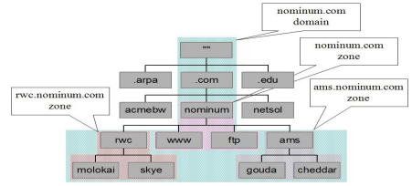

If the domain is not further divided into sub domains then domain and zone refers to the same thing.

The information about the nodes in the sub domain is stored in the servers at the lower levels however; the original server keeps reference to these lower levels of servers.

**1.4.5 Types of Name Servers**

Following are the three categories of Name Servers that manages the entire Domain Name System:

1. Root Server

2. Primary Server

2 SNJB’s Late Sau. K. B. Jain College of Engineering, Chandwad

Computer Network laboratory (2015) Pattern TE Computer 1 TE Computer

3. Secondary Server

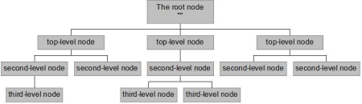

**1.4.5.1 Root Server**

Root Server is the top level server which consists of the entire DNS tree. It does not contain the information about domains but delegates the authority to the other server

**1.4.5.2 Primary Servers**

Primary Server stores a file about its zone. It has authority to create, maintain, and update the zone file.

**1.4.5.3 Secondary Server**

Secondary Server transfers complete information about a zone from another server which may be primary or secondary server. The secondary server does not have authority to create or update a zone file.

**2.1 How does DNS work?**

DNS servers answer questions from both inside and outside their own domains. When a server receives a request from outside the domain for information about a name or address inside the domain, it provides the authoritative answer. When a server receives a request from inside its own domain for information about a name or address outside that domain, it passes the request out to another server -- usually one managed by its internet service provider. If that server does not know the answer or the authoritative source for the answer, it will reach out to the DNS servers for the top-level domain -- e.g., for all of .com or .edu. Then, it will pass the request down to the authoritative server for the specific domain -- e.g., techtarget.com or stkate.edu; the answer flows back along the same path.

**2.2 How DNS Lookup Works**

By now, you know that there are different servers hosting databases that contain the IP addresses of different domains and their sub-domains. You also know that there are Root Servers that hold the IP address of servers hosting Top Level Domains. These Root Servers help in reaching the servers containing databases that hold IP address of the main domain name. If there are sub-domains, their address can be on the same servers as of the main domain name or on a different server. All these servers are accessible for finding out the IP address of the exact URL that you need to use.

∙ **Forward Lookup:** When a name query is send to the DNS server against to IP address, it is generally said a forward lookup.

3 SNJB’s Late Sau. K. B. Jain College of Engineering, Chandwad

Computer Network laboratory (2015) Pattern TE Computer 1 TE Computer

∙ **Reverse Lookup:** DNS also provides a reverse lookup process, enabling clients to use a known IP address during a name query and look up a computer name based on its address.

**The process of finding out the IP address of any URL on the Internet is known as DNS lookup**.

To find out how DNS Lookup works, take the following example.

**Example:** Consider a network of ten computers. Each computer has its own address so that data packets travelling in the network know where to go. There is a 11th computer that hosts a database containing the alias names of each of these ten computers and their IP addresses. While the computer users can refer to the computers using their names, the data packets need the IP addresses of the computers so that they can reach the intended recipient. If computer A needs to use the printer attached to computer B, A will check the database on 11th computer to know the IP address of B and then find out the address of printer attached to B. Only after obtaining the address of the printer, A will route the print command to printer attached to B.

In this case, the following iterations happen:

**A** contacts Computer **11**

**A** contacts **B**

**A** contacts printer attached to **B**

A similar method is used to lookup DNS records. For example, when you click on http://snjb.org, your router will contact your default DNS Service for DNS resolution. The DNS service will contact Root Servers and ask for the IP address of server containing **.org** records. This address is sent back to your DNS service. The DNS service again reaches the Name Server containing addresses of **.org** domains and asks it for the address of http://snjb.org. Upon obtaining the IP address of the servers that host snjb.org, your DNS service will return the IP address to your computer which then fires up your browser to download the main webpage. This means your DNS service is sending at least two requests to receive the IP address of a simple domain name.

**Following is an image that explains how DNS lookup works:**

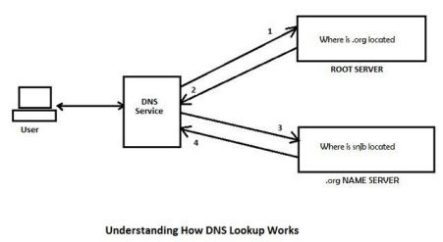4 SNJB’s Late Sau. K. B. Jain College of Engineering, Chandwad

Computer Network laboratory (2015) Pattern TE Computer 1 TE Computer

In the above case, if you were to look for http:// http://snjb.academiaerp.com/snjb/Login , your DNS service had to run a request extra to know its IP address.

Since resolving DNS from scratch every time takes up time, many ISPs and DNS Service Providers create local caches that contain already resolved addresses. These are primarily the addresses they already fetched from Root Servers and other Name Servers at some point of time. In this case, when you send a request for a URL, instead of contacting the Root server directly, the DNS service would look up for the resolved address of the URL in its local DNS cache. If found, it would send the resolution back to your computer instantly else would go ahead and resolve the DNS using the above method of contacting Root Servers and other Name Servers.

Some operating systems too contain a local cached copy of addresses that you commonly use on your computer. This too, helps in saving time while using the Internet. We will talk about DNS caches in a different article at some later point of time.

**Assignment Question:**

1. Explain the need of DNS system in internet word.

2. What is the website’s IP address ?

3. What are a Forward and Reverse Lookup?

4. What is primary, Secondary, stub & AD Integrated Zone?

5. Explain the DNS hierarchy.

6. What is the host.txt?

**Conclusion:**

Hence we conclude that we have lookup the URL which we want to visit the request is travels to local router to DNS server and it resolve the query as possible otherwise it forwards the query to next DNS hop.